Git initials

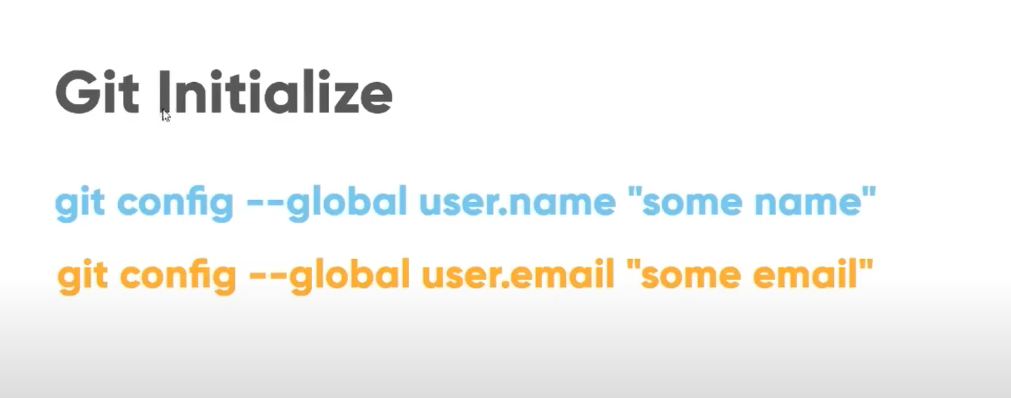

git config --global user.name “some name”

git config –global user.email “some email”

Create a new repository and run this command

echo "# about-git-gitbub" >> README.md

git init

git add README.md

git commit -m "first commit"

git branch -M main

git remote add origin https://github.com/ronak5177/about-git-gitbub.git

git push -u origin main or git push –u origin master

Other way

git init

git status

git commit -m "update commit"

git remote add origin <https://github.com/ronak5177/about-git-gitbub.git>

git push –u origin master